

Job description
Job title: Governance and Executive Support Officer
Job location: Andover, with the potential for some home/hybrid working
Reports to: CEO
Number of direct reports: None
Financial responsibility: Up to 5K p.a.
Level of disclosure check: Basic Level

Overall purpose
Every day, around 300 people are diagnosed with macular disease. It’s the biggest cause of sight loss in the UK.
Macular disease is cruel and isolating. It steals your sight, your independence, and your ability to do the things you love.
It can affect people of any age — even children — but not enough is known about why, and there is still no cure.
Role description
The Governance and Executive Support Officer is a key role in enabling effective governance and leadership across the Macular Society.

The post holder reports to the CEO and works closely with the Senior Leadership Team and Boad of Trustees.

Our values

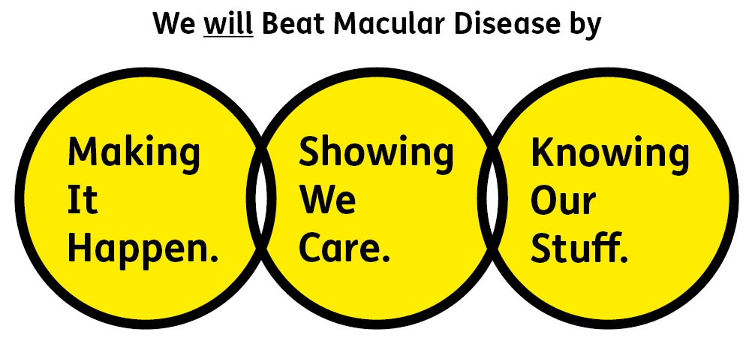

Showing We Care
We are supportive and caring
Knowing Our Stuff
We have integrity and we act honestly
Making It Happen
We are ambitious

Key accountabilities of the role

Meeting support and management
Working with the CEO and Senior Leadership Team (especially the Director of Finance and Governance) to plan and support meetings of our Board of Trustees, it’s 3 committees (Audit and Risk; Finance and Fundraising; and Governance, Nominations and People) and our Senior Leadership Team.
This will include ensuring that effective workplans are in place for each group, that papers are prepared and circulated in good time, that accurate minutes are produced, and that actions are implemented.

Organisational resources
Owning and managing key organisational resources such as our risk register, compliance register and policy register, ensuring that they are kept regularly updated by the Senior Leadership Team and discussed by the Board or its committees when appropriate.

Organisational governance
Supporting the Director of Finance and Governance to coordinate our organisational governance. Including preparations for AGMs, the review and updating of our governing documents, and communication with regulators such as the Charity Commission and Companies House.

Policy coordination
Coordinating the development and review of organisational policies and procedures, ensuring that policy owners adhere to agreed review cycles, that policies are approved by the appropriate committees, and that policies are communicated to staff.

Internal communications
Supporting the CEO with internal communications – including collating material for the weekly update to staff, planning quarterly all-staff meetings, and the monthly all-staff newsletter.

Travel booking
Planning and booking travel and accommodation for the CEO and where required for Trustees. Processing Trustee expense claims.

Diary management
Supporting the CEO to manage their diary, including handling meeting requests and arranging meetings as required by the CEO.

Administrative support to the CEO
Where required providing administrative support to the CEO, including filing documents, preparing correspondence and hosting visitors.

Person specification

Essential:

Experience and knowledge:
Experiencing of supporting complex meetings and proving high-quality governance support.
Experience of supporting a CEO or other senior leader, and an understanding of how high-quality support can enable effective leadership.

Skills and abilities:
Highly organised, with the ability to plan ahead, manage competing priorities and respond to urgent requests.
Strong IT skills, with the ability to use new technology platforms to work effectively and enable collaboration across an organisation.
Ability to quickly grasp complex information and recognise interdependencies across a programme of work.
An excellent communicator, who is able to communicate complex issues with clarity and concision to senior stakeholders including Trustees.
A natural collaborator, who is able to work alongside colleagues in a wide-range of roles in an effective and engaging way. Excellent interpersonal and diplomatic skills.
Excellent attention to detail, and the ability to draft formal organisational documents and minutes.
Tact and diplomacy and the ability to deal with confidential matters with discretion.
Understanding of the charity sector and charity governance.

Desirable:
Knowledge of the sight loss sector/macular disease and/or understanding of sight loss.

Eligibility to work in the UK:
Proof of identity and eligibility to work in the UK.

Volunteering:
From time to time you may be asked to support / volunteer your time (TOIL available) at Macular Society events that take place outside of normal working hours.
Location: The role is based in our Andover, and attendance at our office will be required to support meetings and other activities. However, when not required in the office the post holder will be able to work from home.
Salary: £39,000 - £41,000 (depending on experience)
Contract Type: Permanent
Annual leave: 26 days plus bank holidays (pro rata for part time)

