Job description

Job title: Community Engagement Manager Wales
Team: Community Engagement Team
Department: Services
Job Location: Home-based – Wales
Reports to: Senior Community Engagement Manager NI
Salary: £31,000-£33,000 per annum
Level of disclosure check required and related workforce: Basic

Overall purpose
Macular disease is the biggest cause of sight loss in the UK, with around 300 people diagnosed every day. The Macular Society is the only charity determined to beat the fear and isolation of macular disease with world class research, and the best advice and support.

To support people affected by macular disease now, the Macular Society provides a range of support, information, and services. Our research programme is focused on finding new treatments and a cure to Beat Macular Disease forever.

The Community Engagement team is responsible for supporting local community groups, strengthening volunteer networks, and fostering partnerships with the wider community.
The team is designed to strengthen relationships with volunteers, local organisations and stakeholders while driving innovative solutions to support community needs. Welsh language skills are highly desirable for this role.

Organisational chart

The Director of Services leads the team structure at the top. Reporting directly to the Director is the Head of Community Networks. The Senior Community Engagement Manager reports to the Head and oversees the Community Engagement Manager – Wales.

Our values
We will beat macular disease by…

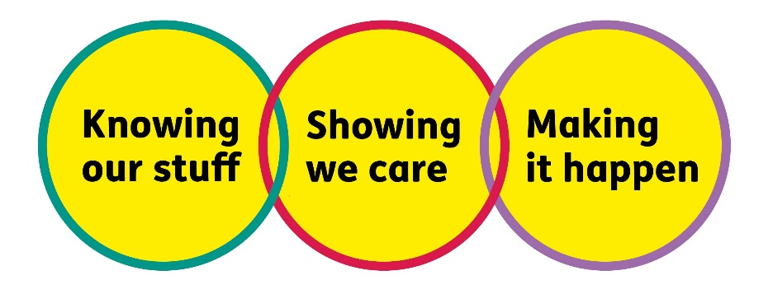

Making It Happen - we are Ambitious

Showing We Care - we are Supportive and Caring
- Knowing Our Stuff - we have Integrity, and we act Honestly

Key accountabilities of the role:
- Support the development of local community-based support and peer networks, ensuring they have the resources, guidance and structure needed to thrive.
- Lead and coordinate community engagement within the allocated nation, ensuring that local insight and community needs inform national approaches.
- Support volunteers, working closely with the volunteer and group support team to ensure they are engaged, informed and confident in their roles.
- Engage, build, and nurture relations with key stakeholders and influencers at both a regional and national level to ensure that macular disease is a strategic priority
- Facilitate a face-to-face volunteer networking event in Wales.
- Work with the fundraising team on funding opportunities
- Provide macular-specific advice, information and learning to external partners and stakeholders to enhance understanding and influence service delivery.
- Be knowledgeable and up to date on local and universal services to signpost/refer people accordingly.
- Foster and maintain good working relations with members of the internal team(s).
- Gather and share insight from volunteers and communities to inform service development and support strategic decision-making across the organisation.
- Promote equality, diversity, and inclusion in all aspects of engagement, ensuring volunteer-led activity is accessible, welcoming, and reflective of the communities we serve.

- Specifically for this role, you will have:

Knowing Our Stuff
- Experience in service delivery and management of budgets
- A strong understanding of the context in the nation being supported, and how this shapes the experiences of groups and volunteers.
- Ability to gather insight from communities and contribute this to team-wide learning and strategic planning.
- Experience of providing information in various formats – print/digital.
- An understanding/willingness to develop an understanding of macular disease and the impact of macular disease on both those diagnosed and those caring.

Making It Happen
- Experience in approaching, building, developing, and working with a diverse range of organisations.
- Effective planning and facilitation of events such as a volunteer networking event and community meetups.
- Constructive partnership working with the Volunteer and Group Support Team to ensure a joined-up approach to supporting volunteers.
- Collaborative working with colleagues and partners to support innovation, shared learning, and continuous improvement.
- Experience of influencing others from a cross-section of the community.
- Ability to work independently under own initiative and cooperatively as part of a team
- Ability to multitask and prioritise multiple projects and work streams.
- Strong IT skills, including Word, Excel, PowerPoint, and Outlook.

Showing We Care
- Development of strong, trusted relationships with local groups, volunteers, and partners, built on respect and active listening.
- Creation of opportunities for connection, support, and belonging within the volunteer network.
- Active promotion of inclusion and accessibility across all engagement activities.
- Ongoing advocacy for community voices to shape how support is delivered and how the model continues to evolve.

Eligibility to work in the UK:
Proof of identity and eligibility to work in the UK.
Travel:
You will be expected to travel across your designated nation or region and to attend occasional events at the Andover office.

Volunteering:
From time to time, you may be asked to support / volunteer your time (TOIL available) at Macular Society events that take place outside of normal working hours.

Safeguarding:
The Macular Society is committed to safeguarding and promoting the welfare of all children, young people, and vulnerable adults with whom we work. We expect all of our employees and volunteers to demonstrate this commitment.
You are required to carry out other such duties as may reasonably be required, relevant to the role.
This job description is accurate as at the date shown below. In consultation with you it is liable to variation by the Macular Society to reflect or anticipate changes in or to the role.

Annual leave: 26 days plus bank holidays (pro rata for part-time)
Based: We are seeking a candidate who is ordinarily resident in Wales to support our work across the country. This role is home based.
Contract Type: Permanent
Date of evaluation: Dec 2025

