# Job description

## General information

**Job title**: Head of Trusts & Philanthropy

**Team**: Trusts & Philanthropy

**Department:** Fundraising & Marketing

**Job location:** Andover or Home Based

**Reports to:** Director of Fundraising & Marketing

**Number of direct reports:** 2 (becoming 3)

**Number of volunteer reports:** 0

**Financial responsibility:** combined income of c£700,000

**Matrix reporting lines to:** N/A

**Salary:** £

**Level of disclosure check required and related workforce:**

Basic

## Overall purpose

Every day, around 300 people are diagnosed with macular disease. It’s the biggest cause of sight loss in the UK. Macular disease is cruel and isolating. It steals your sight, your independence, and your ability to do the things you love. There is only one way to Beat Macular Disease for good.

The Macular Society is working to deliver our ultimate ambition – to Beat Macular Disease for the next generation. We are determined to end the fear and isolation of macular disease with world-class research and the best advice and support.

## Organisational chart

The chart above shows the Head of Trusts & Philanthropy at the top (who reports into the Director of Fundraising & Marketing) with the following roles reporting into that post: Trusts & Philanthropy Manager x2 and Major Donor Manager (who is likely to be recruited in early 2026). In addition, one of the Trust & Philanthropy Managers has a Trusts & Philanthropy Officer reporting to them.

## Our values

We will beat macular disease by…

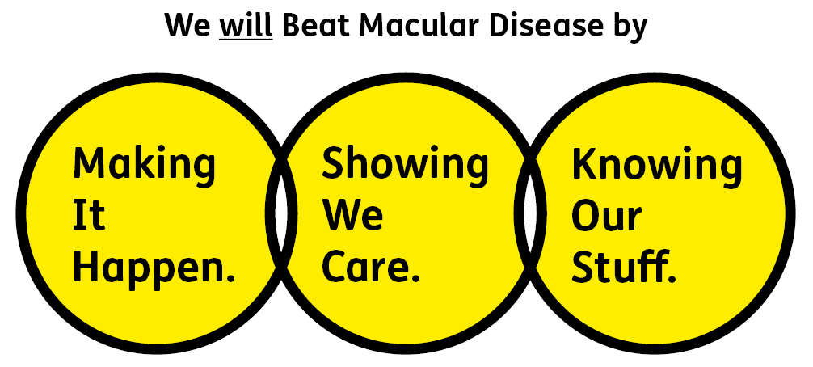

### Showing We Care - we are Supportive and Caring

### Knowing Our Stuff - we have Integrity and we act Honestly

### Making It Happen - we are Ambitious

## Key accountabilities of the role

* Develop and implement a strategy to secure significant income from trusts, foundations, lottery and high net worth individuals.
* Develop and implement a strategy for identifying high net worth individuals with a propensity to support the Macular Society.
* Develop robust cultivation and stewardship plans to build positive, income-generating, long-term relationships with key funders and supporters.
* Support the Trusts & Philanthropy Managers to enable and support a driven and effective team.
* Develop a robust pipeline of funding bids and individuals.
* Produce and implement strategic and tactical plans that increase the amount of income that is generated annually from trusts, foundations and high net worth individuals.
* Deliver income targets and expenditure budgets for trusts, foundations and high net worth individuals and be responsible for monitoring progress and setting the budget on an annual basis.
* Research, plan and write funding bids and proposals to trusts, foundations, lottery and high net individuals including evidence of need, project plans, budgets and other related information.
* With the Director of Fundraising & Marketing, set and monitor relevant KPIs for both short and long-term growth.
* Ensure all funders receive regular and timely reports on progress, utilising our soon-to-be-implemented CRM platform - Microsoft dynamics - to oversee a co-ordinated approach to recording and monitoring grants and reporting to funders.
* Work creatively with colleagues and external partner organisations to develop high quality proposals to maximise new/emerging opportunities.

All employees are expected to comply with Macular Society terms and conditions, rules, policies, procedures, codes of conduct, quality standards, authorisation processes, risk management policies etc. and relevant external regulations.

## Competencies

1. Supports and manages their team and colleagues

2. Works well with others across the Macular Society

3. Is committed to quality and service

4. Understands how the Macular Society operates and follows agreed procedures

5. Delivers their objectives and core activities as required

6. Takes responsibility for their own performance and development

## Person specification

### Essential:

Knowing Our Stuff

* Track record of success in securing funding from trusts, foundations and high net worth individuals
* In depth knowledge of the fundraising environment and of a range of techniques and disciplines which will support the cost-effective generation of income
* Demonstrable experience of identifying high net worth individuals and developing them as major donors
* Experience of writing and delivering successful bids and of managing a portfolio of funders
* Strong IT skills including Word, Excel, PowerPoint, Outlook.

Making It Happen

* Strong analytical and strategic planning skills, be a confident communicator and have an in-depth knowledge of the fundraising market and regulation
* Ability to work independently under own initiative and cooperatively as part of a team
* Ability to multitask and prioritise multiple projects and work streams.
* Experience of grants administration and the management of onward grants

Showing We Care

* Excellent team working and collaborative working skills and the ability to develop effective partnerships.
* Commitment to high standards in all areas of work.

Eligibility to work in the UK:

Proof of identity and eligibility to work in the UK.

## Volunteering:

From time to time you may be asked to support / volunteer your time (TOIL available) at Macular Society events that take place outside of normal working hours.

## Safeguarding:

The Macular Society is committed to safeguarding and promoting the welfare of all children, young people and vulnerable adults with whom we work. We expect all of our employees and volunteers to demonstrate this commitment.

The post holder is required to carry out other such duties as may  
reasonably be required, commensurate with the grade of this post. All  
employees are expected to excel in being supporter centric,   
demonstrate advocacy for the Macular Society at all times and be a fundraiser.

This job profile is accurate as at the date shown below. In consultation  
with the post holder it is liable to variation by management to reflect  
or anticipate changes in or to the role.

**Annual leave:** 26 days plus bank holidays (pro rata for part time)

**Based:** Andover and or home

**Contract Type:** full time, permanent

**DATE OF EVALUATION:** April 2025

